

**2024-25 Parent and Family Engagement Plan (PFEP) Summary**

Palm Bay Elementary focuses on fostering a safe, caring, and personal environment as the foundation for our students’ academic success. Our curriculum is aligned to the state standards with an emphasis on project-based learning to help our students develop problem solving and critical thinking skills. Our Parent and Family Engagement Plan outlines how we will work alongside parents as valued partners in the educational process.

**Accessibility for all Families**

We strive hard to overcome barriers that prevent parents from participating. The following accommodations will be provided:

**~**Flexible meeting dates and times

**~**More advanced notice for school activities and educational events

**~**Interpreters or bilingual staff members will be available as needed

**~**Translated documents

**Shared Decision Making**

Surveys are distributed throughout the year to gather parent input. Please be on the lookout for surveys so your voice may be heard. The Parent Involvement Team (PIT) consists of parents, community members, school staff and administrators. This committee meets to develop and revise the School Improvement Plan, the Parent and Family Engagement Plan, the School-Parent Compact, and the Title I budget for parent involvement.

**Communication Methods**

We strive to participate with parents in regular, two-way, and meaningful communication! We will use the following methods to disseminate and/or receive information, when feasible, in the format and the language parents can understand:

~Flyers

~Parent Portal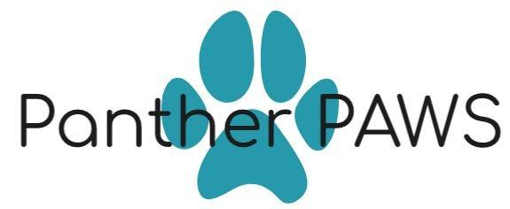

~Class DOJO

~Website/Facebook

~Parent Conferences (in person or virtual)

~Emails/REMIND

~Parent Involvement Team (PIT)

~Surveys

**Parent Information**

Parents need to be “in the know” in order to be involved. We will either distribute information and/or conduct parent workshops to keep parents informed of the following:

~Understanding Florida’s new B.E.S.T. Standards that determines what your child will be learning

~State and local assessments your child will take and what your child is expected to obtain

~Curriculum in use at the school

~How you can monitor your child’s progress

~How to work with school staff to improve the achievement of your child

~Programs available at the school for your child

**Parenting Events**

Be on the lookout for the following parenting events that are planned for this school year. They will provide you with valuable information and resources to work with your child at home.

~24-25 Orientation “Rock the Block”

~Open House

~Parent Portal Training

~Title I Annual Meeting

~Assessment Information Night

~Bingo for Books

~Kindergarten Roundup

~Fifth Grade to Middle School Transition

~Parent Workshops with the Principal

**Staff Training**

We are always looking for ways to improve our relationships with families! Our teachers and staff will receive training on establishing a responsive classroom that focuses on teacher language and the power of our words.

If you are interested in assisting with training, contact Loretta Mistrot, Supervisor of Title I, at [mistrll@bay.k12.fl.us](mailto:mistrll@bay.k12.fl.us) or 850-767-4354.

**Volunteer**

We encourage parents to volunteer! We love our volunteers and use them in various capacities that support the needs of the students and schools. **We believe that education is a partnership between school and home and consistent communication between teachers and parents is key. We believe in high behavioral expectations, character education, and policies and procedures to enhance the learning environment.**

**Improving the Lives of Students Through Authentic Learning Experiences**